Lab 6:
- Create table customer and insert datas.
- Display data whose address is Ayush Address.
- Display information whose buying amount is Gaurav purchase amount.
- Display all distinct phone numbers.
SQL Queries:
- CREATE DATABASE lab6;
- USE lab6;
- CREATE TABLE customer(
Cid INT(3) PRIMARY KEY NOT NULL,
Cname VARCHAR(30),
Caddress VARCHAR(30),
BuyingAmount NUMERIC,
Phone NUMERIC
);
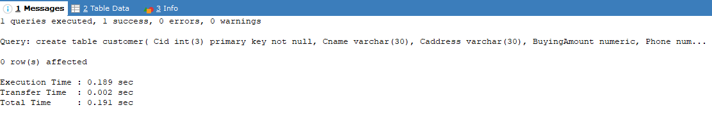

- INSERT INTO customer VALUES
(101,'Abilekh','Mustang',13500,9842776302),
(102,'Alsiha','KTM',1500,9842776302),
(103,'Anshu','KTM',500,9841276302),
(104,'Anush','Gorkha',13500,9843776302),
(105,'Aslesha','KTM',10000,9845776302),
(106,'Ayush','Patan',13000,9878776302),
(107,'Barsha','Lamjung',12000,9882776302),
(108,'Gaurav','KTM',13500,9842776302),
(109,'Diya','Bkt',13500,9847876302)
;
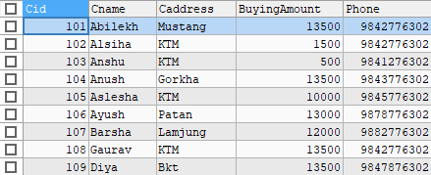
- To display data whose address is Ayush Address.

SELECT *FROM customer WHERE Caddress=(SELECT Caddress FROM customer WHERE Cname='Ayush');
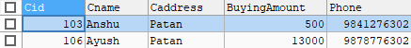

- To display information whose buying amount is Gaurav purchase amount.

SELECT *FROM customer WHERE BuyingAmount=(SELECT BuyingAmount FROM customer WHERE Cname='Gaurav');
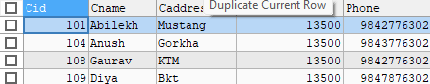

- To display all distinct phone numbers.

SELECT DISTINCT Phone FROM customer;
